# Class Diagram for “Shophoria”

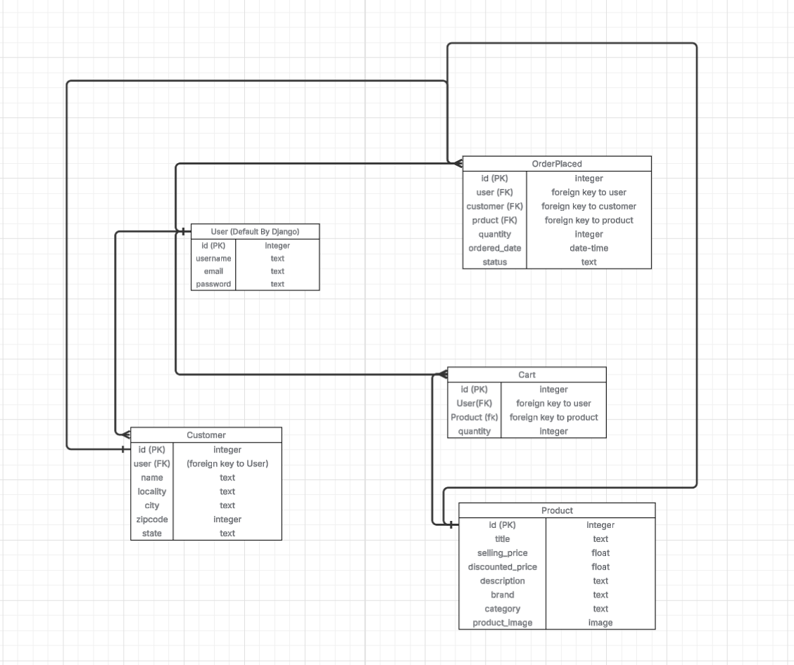

## Relationships

## A Customer belongs to one User (Many Customers → One User).

## A Cart belongs to one User (Many Carts → One User).

## A Cart belongs to one Product (Many Carts → One Product).

## An OrderPlaced belongs to one User (Many Orders → One User).

## An OrderPlaced belongs to one Customer (Many Orders → One Customer).

## An OrderPlaced belongs to one Product (Many Orders → One Product).